專案管理CH1 四資管三A B10523030 簡聿均

------------------------------------- Ch1. Objectives: Modern Project Management-------------------------------

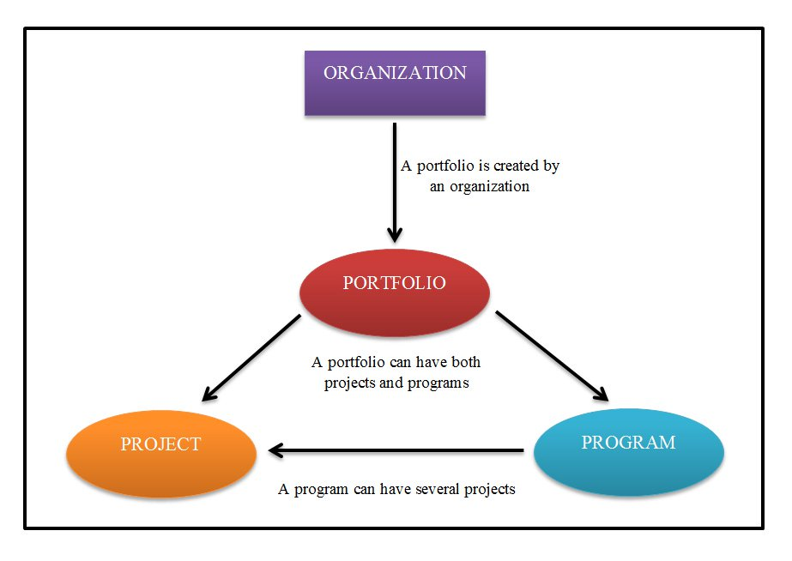

【Project】

專案是在有限的時間、預算、資源和執行上，為客戶的需求做設計與規劃。

A complex, nonroutine, one-time effort limited by time, budget, resources,   
and performance specifications designed to meet customer needs.

專案管理的特性包含  
a.明確的起點、終點的生命週期(life span)  
b.擁有既定的目標及預算控制(成本控制)  
c.明確的工作範疇

d.要展現出特定的成果(specific requirements)

e.跨組織參與(across-the-organizational)

f.有從未做過的事情(something never been done)

專案具有3大特性

(1)臨時 : 有明確的開始及結束日期、完工時團隊就會解散

(2)獨特 : 產出不同於其他產品或服務

(3)完成 : 從概念到規劃，在執行到產出成果

專案的4要件為PCTS

(1)成果 (Performance)

(2)成本 (Cost)

(3)時間 (Time)

(4)範疇 (Scope)

其中「範疇」 = PCT所組成之面積

【Program】

一個流程是有多個相關、多個項目的，是長時間的達成目標。

A series of coordinated, related, multiple projects that continue   
over an extended time and are intended to achieve a goal.

Program跟Project比較:

Project: 比較偏向單一事件的完成。ex.完成專案管理必修課

completion of a required course in project management.

Program: 偏向一系列之事件含有多項專案。ex.完成整個商學院系列課程  
completion of all courses required for a business major.

【Project life cycle】

Defining 
Start 
Defining 
1. Goals 
2. Specifications 
3. Tasks 
4. Responsibilities 
Planning 
Planning 
1. Schedules 
2. Budgets 
3. Resources 
4. Risks 
5. Staffing 
Executing 
Time 
Executing 
1. Status reports 
2. Changes 
3. Quality 
4. Forecasts 
Closing 
End 
Closing 
. Train customer 
2. Transfer documents 
3. Release resources 
4. Evaluation 
5. Lessons learned 

【Project Management Professional (PMP)】

專案管理師又被稱為PM (Project Manager)專案管理經理

主要為專案團隊提供指導，協調和整合(direction, coordination, and integration )

必須要為該專案負責且負責專案的成功(success)

用合適的人解決問題並做出決定(3R: right people in right place make the right decisions)

必須了解

1. Why 為什麼做

2. What 要做什麼

3. How 要怎麼做

【PMBOK 專案管理知識體系導讀】

專案管理遵循：

5大程序群 (Process Groups) 和10大知識體 ( Knowledge Areas)含44個流程

1.起始 (Initiating Processes) – 授權開始一個專案

2.規劃 (Planning Processes) – 選擇最佳行動方法

3.執行 (Executing Processes) – 實行專案計劃

4.控制 (Controlling Processes) – 由定期監督及量測專案進度

5.結案 (Closing Processes) – 正式化一個專案

Initiating 
Process 
Group 
Level of 
Process 
Interaction 
Planning 
Process 
Group 
Executing 
Process 
Group 
TIME 
Mon itoring 
and Controlling 
Process Group 
Closi 
Process 
Group 
Finish 

|  |  |
| --- | --- |
| 1.整合管理 (Integration)  五大程序群 (Process Groups) | 2.範疇管理 (Scope) |
| C:\Users\juck3\AppData\Local\Packages\Microsoft.Office.OneNote_8wekyb3d8bbwe\TempState\msohtmlclip\clip_image004.png | C:\Users\juck3\AppData\Local\Packages\Microsoft.Office.OneNote_8wekyb3d8bbwe\TempState\msohtmlclip\clip_image005.png |
| 3.時間管理 (Time)  要徑法、甘特圖、時間表 | 4.成本管理 (Cost )  專案成本金字塔 |
| C:\Users\juck3\AppData\Local\Packages\Microsoft.Office.OneNote_8wekyb3d8bbwe\TempState\msohtmlclip\clip_image006.png | C:\Users\juck3\AppData\Local\Packages\Microsoft.Office.OneNote_8wekyb3d8bbwe\TempState\msohtmlclip\clip_image007.png |
| 5.品質管理 (Project Quality) 分為7種圖：魚骨、  控制、流程、直方、柏拉、散佈、查檢圖 | 6.人力資源管理 (Human Resource)  層級結構圖、RACI矩陣 |
| C:\Users\juck3\AppData\Local\Packages\Microsoft.Office.OneNote_8wekyb3d8bbwe\TempState\msohtmlclip\clip_image008.png | C:\Users\juck3\AppData\Local\Packages\Microsoft.Office.OneNote_8wekyb3d8bbwe\TempState\msohtmlclip\clip_image009.png |
| 7.溝通管理 (Communications) | 8.風險管理 (Risk) |
| C:\Users\juck3\AppData\Local\Packages\Microsoft.Office.OneNote_8wekyb3d8bbwe\TempState\msohtmlclip\clip_image010.png | C:\Users\juck3\AppData\Local\Packages\Microsoft.Office.OneNote_8wekyb3d8bbwe\TempState\msohtmlclip\clip_image011.png |
| 9.採購管理 (Procurement) | 10.利害關係人管理(Stakeholder) |
| C:\Users\juck3\AppData\Local\Packages\Microsoft.Office.OneNote_8wekyb3d8bbwe\TempState\msohtmlclip\clip_image012.png | C:\Users\juck3\AppData\Local\Packages\Microsoft.Office.OneNote_8wekyb3d8bbwe\TempState\msohtmlclip\clip_image013.png |

Process Groups Interact in a Phase or Project (PMBoK)

Enter Phase/ 
Start project 
Monitoring & 
Controlling Processes 
Planning 
Processes 
Initiating 
Processes 
Executing 
Processes 
Closing 
Exit Phase/ 
End project 

Project Management Process Interactions (PMBoK)

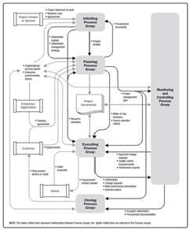

Project Boundaries (PMBoK)

project 
Initiator/ 
Sponsor 
Project 
Boundaries 
Project 
Inputs 
Project 
Deliverables 
Project 
Records 
End 
Users 
Process 
Assets 

Project Data, Information and Report Flow (PMBoK)

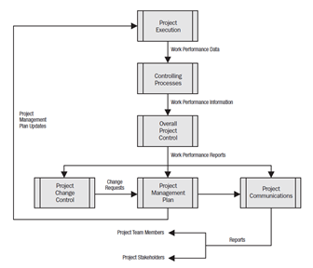

Project Management Process Group and Knowledge Area Mapping (PMBoK)

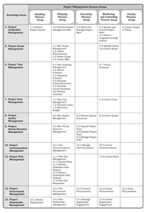

Integrated Management of Projects

Organizational Culture 
Environment 
Strategic 
Alignment 
Portfolio 
Management 
Project 
Management 